Task 2: Deep Learning Project

Objective: To build a deep learning model using neural networks for digit recognition.
Dataset Used: MNIST Handwritten Digit Dataset
- Tools & Technologies Used:
Python
- TensorFlow
- Keras
- NumPy
- Google Colab
Libraries Used:
tensorflow
keras.layers
numpy
- Steps Performed:
- Loaded the MNIST dataset
- Normalized image pixel values
- Built a Neural Network model
- Added input, hidden, and output layers
- Compiled the model
- Trained the model using training data
- Evaluated model performance
- Tested accuracy on unseen data
Output:
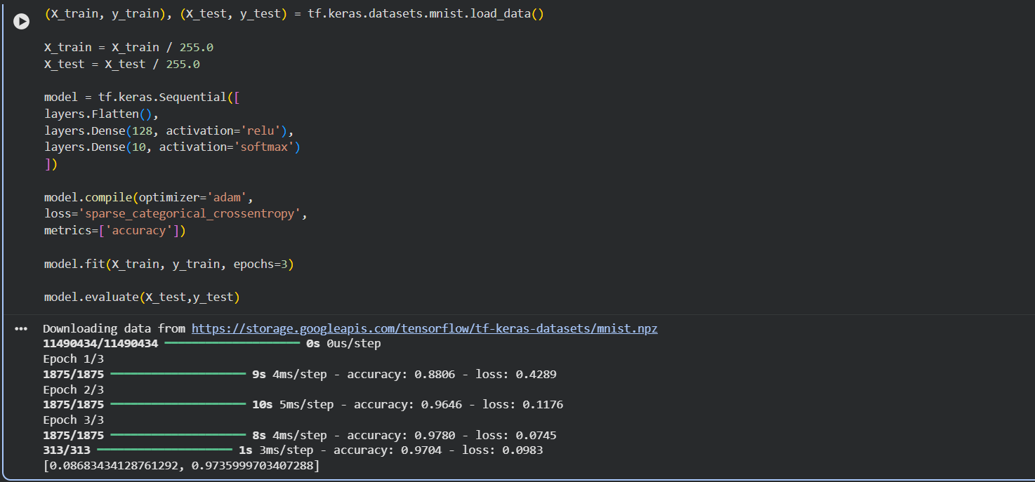
Result
The Deep Learning model was successfully trained and tested.
It achieved high accuracy in recognizing handwritten digits.

